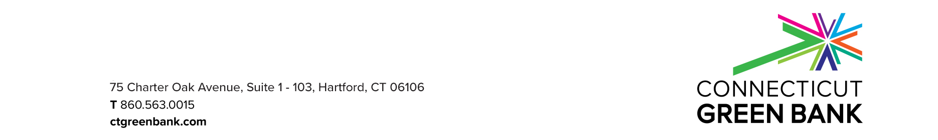

Application
for
RGM Upgrade Provider RFP

for

Residential and Commercial Solar Programs, including the Residential Solar Investment Program (RSIP) and RSIP Extension (RSIP-E)

Program Opportunity # CGB-RGMUP-2021
May 21, 2021

Applications accepted from June 1, 2021 through June 21, 2021
Questions or clarifications about this document should be directed to:

Connecticut Green Bank (Green Bank)
Incentive Programs
75 Charter Oak Avenue Suite 1-103
Hartford, CT 06106
Telephone: 860.563.0015
Fax: 860.398.5510
E-mail: smallsolar@ctgreenbank.com

This document is available on the following Green Bank Web page:
http://www.ctgreenbank.com/about-us/open-rfps

Form A – Application Certification

The undersigned is a duly authorized representative of the RGM Upgrade Provider
(“Provider”) listed below with the authority to bind the applicant for the purposes of this Request for Proposals (RFP). The Applicant has read, understands and agrees to be bound by the terms and conditions contained in this solicitation.

The information provided by the Provider in this Application or any part thereof, including its exhibits, schedules and other documents or instruments delivered or to be delivered to the Connecticut Green Bank (Green Bank), are true, accurate and complete. This Application includes all information necessary to ensure the statements therein do not in whole or in part mislead the Green Bank as to any material fact.

I certify:

- The statements made by Provider in this Application, including all attachments, forms and exhibits, are true and correct to the best of my knowledge.

- The Application is not made in connection with any competing Provider submitting a separate response to this solicitation and is without collusion or fraud.

- The RGM Upgrade Provider has not been convicted of bribery or attempting to bribe a public official or employee of the state, has not been disqualified for contract awards by any agency of the state, and is not in default under any contract with an agency of the state.

- The Provider does not have an affiliation or relationship, financial or otherwise, with any other Provider under this program except as disclosed in Form B of this Application.

- The Provider acknowledges that the Green Bank is a “public agency” for purposes of Connecticut’s Freedom of Information Act (FOIA), and that all information provided to the Green Bank by the Provider is a “public record or file” subject to public disclosure unless exempted by the FOIA.

Legal name of Provider:
Name of Provider’s authorized representative:
Title:
Signature of Provider’s authorized representative:

________________________________
Date signed:
Form A – Applicant Information

Applicant Contact Information

Primary Contact

Company Name:

Street Address 1:

Street Address 2:

City: State: Zip:

Phone: Fax:

Email: Website:

Technical Support Contact

Contact Name:

Phone:

Email:

Customer Support Contact

Contact Name:

Phone:

Email:

Application Checklist
- Complete Application – signed Form A
- Form B – Applicant Information per the RFP document, created by Applicant
- Form C – Product-Specific Data per the RFP document, created by Applicant
- Financial Information
- General Liability Insurance Information

Note that Form B and C should be documents created by Applicant that provide all the information requested in the RFP document.

Application Format and Delivery

Application Delivery:

Applications will only be accepted in electronic format, and must be submitted to smallsolar@ctgreenbank.com. Applications must be submitted as complete packages, not piecemeal (e.g., one PDF file that includes all forms, except those marked confidential). Material requested to be confidential must be in a separate PDF, labeled “CONFIDENTIAL” in the title of the document, and clearly marked “CONFIDENTIAL” on each page as it prints, in accordance with Section 5.6 of this RFP, the example Professional Service Agreement, item 17 on the Freedom of Information Act.

Application Format:

All Applications must conform to the following format guidelines:
- 12-point font, 1.5-line spacing, standard 8.5 X 11” paper
- No handwritten Applications
- PDF format only

Application Content Requirements:

An Application will include a complete set of forms and all additional documentation as required.

Application Instructions:

All Applications must include a complete set of forms and attachments for each PDP. Using the forms will ensure consistency in PDP Application submission, interpretation and evaluation. Information requested on each of the forms must be completed in detail and cannot refer to other sections of the Application, even if the information is redundant.

Questions or clarifications about this document should be directed to:
Connecticut Green Bank (Green Bank)
Incentive Programs
75 Charter Oak Avenue Suite 1-103
Hartford, CT 06106
Telephone: 860.563.0015
Fax: 860.398.5510
E-mail: smallsolar@ctgreenbank.com

