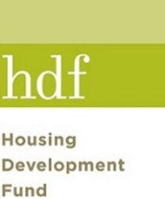
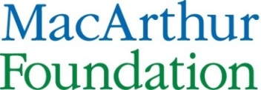
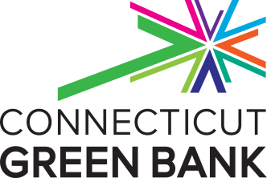
SHERPA / NAVIGATOR PRE-DEVELOPMENT LOAN APPLICATION
CONNECTICUT GREEN BANK
- Property Information
Property Address: _____________________________________________________
Property name (if any): _____________________________________________________
Owner: _____________________________________________________
Contact name: _____________________________________________________
Contact phone: _________________ Contact email: ____________________

Management Company: _______________________________________________
Contact name: _______________________________________________
Contact phone: ________________ Contact email: _____________________

No. of buildings in property: __________________ No. of apartments: _______
No. of floors: __________________ Gross square footage: ____________________
Additional Structures: _______________________________________________
Years in Current Ownership: __________________
Is the building currently occupied? YES NO
If YES/NO, for how long? __________________

Project type (circle one): Renovation/Upgrade New Construction
Building use (circle one): Residential Tenant Mixed Use
Are you considering solar PV as part of your prospective energy upgrades? YES NO
If YES, what is the age of the building(s) roof? ______________
For how long do you plan to continue to own this property? ____________________________
- Tenant Income Information
Is the multifamily property considered affordable or market rate housing? Please circle one:
Affordable Market Rate
c. Project Information

- Are you planning to pursue major building renovations at this time or in the near future (including, but not limited to, wall or ceiling improvements, HVAC system upgrades, etc.)? – please list and describe all that apply

- To your knowledge, has prior energy efficiency work been performed on the building(s) at this property? Are there specific energy upgrade measures or work you would like to evaluate?

- What is your projected timeline for project development?

4. Please describe the energy-related technical pre-development services for which you are seeking financing through this application.

5. Please provide an estimate of the cost of these services (if known at this time).

6. Provide any other important information, including any upcoming refinancing plans or constraints on doing work this year.

d. Technical Assistance
- Are you interested in project pre-development technical assistance from the CT Green Bank’s pre-qualified energy consultant New Ecology, Inc., or do you plan to coordinate technical assistance on your own? (circle one)
  - I am interested in pre-development assistance from New Ecology, Inc.
  - I plan to coordinate my project’s technical assistance:

- In the below form, please list any professional firms (engineering, design, finance, etc.) that you plan to engage to assist you in evaluating, scoping, financing and implementing your prospective energy upgrades.

PROFESSIONAL SERVICE PROVIDERS

Name of Firm: Contact Name:
Address: Phone:
Website: Email:
Services:

------------------------------------------------------------------------------------------------------------------------

Name of Firm: Contact Name:
Address: Phone:
Website: Email:
Services:

------------------------------------------------------------------------------------------------------------------------

Name of Firm: Contact Name:
Address: Phone:
Website: Email:
Services:
CERTIFICATIONS BY THE OWNER
The Connecticut Green Bank will require these certifications by the owner as part of the underwriting of any Multifamily Energy Loan:
- That the Owner and its Principals (greater than a 10% interest) are not debarred from doing business with the Federal Government or with the State of Connecticut.
- That the mortgage payments are current and that mortgages are not in default. If payments are not current or if any mortgages are in default for any other reasons, the Owner must submit a plan to bring them current.
- That the Owner and property are in compliance with any relevant regulatory agreements.
- That property taxes or PILOT payments are current. If taxes are not current, the Owner must submit a plan to bring them current.
- That appropriate property insurance is in place and that payments are current.
- Disclosure of any litigation against the property or the Owner.

FREEDOM OF INFORMATION ACT NOTICE
The Connecticut Green Bank is a “public agency” for purposes of the Connecticut Freedom of Information Act (“FOIA”). Accordingly, this application and all information received by the Green Bank regarding this application will be considered public record subject to disclosure under the FOIA, except for information falling within one of the exemptions in Conn. Gen. Stat. Sections § 1-210(b) and § 16-245n(d), which include “trade secrets” and “commercial or financial information given in confidence, not required by statute.”
Therefore, Applicant is advised that it should specifically identify those particular sentences, paragraphs, pages, sections or exhibits that it claims to be confidential and exempt.
Applicant acknowledges that the Green Bank has no obligation to notify the Applicant of any FOIA request received and the Green Bank may disclose materials claimed by the Applicant to be exempt, if in its judgment, such materials do not appear to fall within a statutory exemption.
NOT A COMMITMENT

It is understood that acceptance of this application by the Green Bank does not represent a commitment to lend or create any legally enforceable obligation on behalf of the Connecticut Green Bank. The Connecticut Green Bank will not share any information received with third parties except as needed to obtain any owner requested financing.

By signing below, I certify that there is no bar to the building receiving assistance from any governmental agency and that the owner(s) of the building or its principals are not under any government investigation. I further acknowledge that this is an application for a commercial loan and the funds will not be used for personal, residential or consumer purposes.

Applicant’s Signature _____________________________ Date__________________________
Printed Name _____________________________

Defined as 60% or more of the housing units in the property serve tenants with incomes less than 80% of Area Median Income (AMI)

